D&E WOMEN'S SOCCER — TEAM SOCIAL MAP | PULSE REPORT | 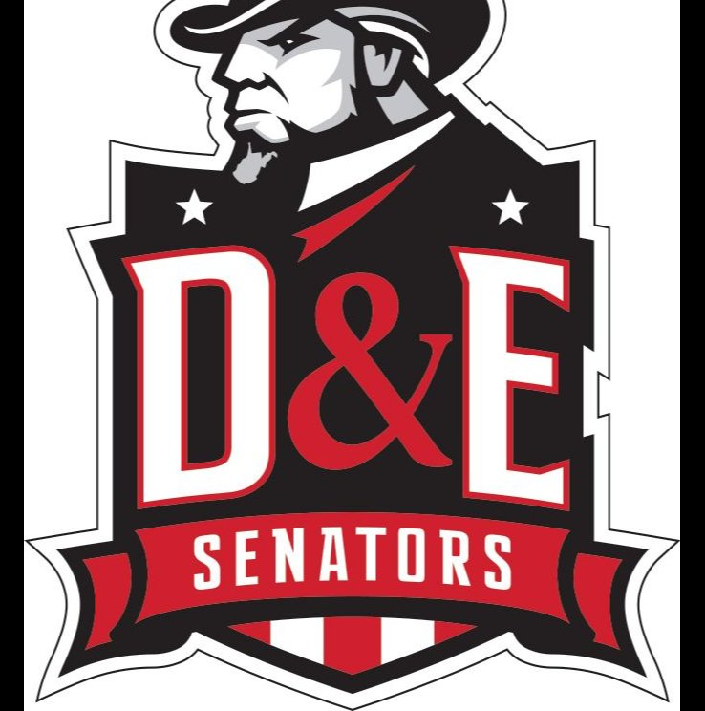
Spring 2026 | 26 Players | 12-Question Peer Nomination Survey | Confidential

12  Core Influencers | 6  Potential Rejection Risk | 8  Potential Isolation Risk | 0  Polarizing Figures
★ STRONGEST SOCIAL ANCHORS  Brenda Castro 25 positive mentions — highest on the team by a significant margin. Nominated across multiple dimensions by virtually every teammate. Minimal friction (1 neg).  Maya Rayma & Rafa Leão 19 positive mentions each. Widely trusted, influential, and low friction across the squad.  Gabriela Acevedo & Kristia Koupp 15–16 mentions each. Strong secondary pillars with near-zero friction.  The top 5 players absorb a disproportionate share of all positive nominations — the team's cohesion leans heavily on a small core.  ⚠ FRICTION & REJECTION RISK  Leni Schmitfranz 25 negative mentions — nominated by every single teammate in a friction dimension. Only 3 positive mentions. The most significant interpersonal risk in the dataset.  Valeria Gabrie (13 neg) High friction with limited peer support. Well above the team average of 3 negative mentions.  Lydia Andrzejuk (12 neg) Similar profile — low social support combined with elevated friction.  Olivia Jones (6 neg) Moderate friction, limited positive recognition. Worth monitoring.  ○ ISOLATION RISK  8 players Carolyne Mathenia, Liliya Akhremenko, Vivian Kerr, Hanna Tomas, Manuella Cogliatti, Rylie Galterio, Carla Tegner, Laufey Kristinsdottir are socially quiet — low friction but also low connection. Risk drifting from team culture without active inclusion. | ◉ CONNECTIVITY MAP — KEY PATTERNS  Dense positive network Core Influencers sit at the centre of the green connection web, with relationship lines radiating outward to most of the squad — confirming their role as the social glue of the team.  Concentrated negative lines The purple dashed (negative) arrows are heavily directed toward Leni Schmitfranz, Valeria Gabrie, and Lydia Andrzejuk — visually isolating them on the network map.  No polarizing figures Zero players combine high influence with high friction — a healthy structural signal.  ▬ INFLUENCE & FRICTION BREAKDOWN — KEY READS  Positive leaders Brenda Castro's green bar (25) stands alone on the right. Maya Rayma & Rafa Leão form a clear second tier at 19.  Friction outliers Leni Schmitfranz's purple bar extends to –25, visually dominant over all others. Valeria Gabrie (–13) and Lydia Andrzejuk (–12) are the only other players with bars extending significantly to the left.  Balanced majority Most players show modest positive bars with negligible negative bars — the team's baseline health is good, with friction concentrated in a small group.  → SUGGESTED CONSIDERATIONS  • Consider a private conversation with Leni Schmitfranz— her friction score is a significant outlier and worth understanding before drawing conclusions.  • Check in individually with Valeria Gabrie and Lydia Andrzejuk— understanding what is driving their friction scores may reveal fixable dynamics.  • Intentional grouping— bringing Isolation Risk players into closer proximity with Core Influencers in training and team activities may help build connection naturally.  • Distribute leadership visibility— with cohesion leaning heavily on a small core, broadening who carries social responsibility could strengthen overall team resilience.
Confidential — For coaching staff use only. All data is self-reported by players through peer nomination. Results are intended as a starting point for conversation, not a definitive assessment of any individual.

